REGISTRATION FORM
Jointly organised by DAAD and GIZ Georgia
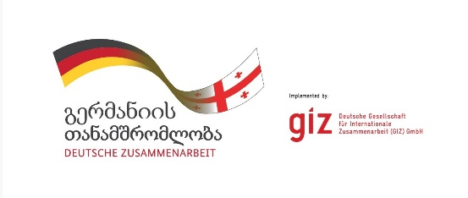

Cooperation between Higher Education and the Labour Market
Strengthening Employability and Implementation in Curriculum Development
19–20 October 2026, Tbilisi, Georgia
Venue: Rooms Tbilisi, 14 Merab Kostava St, Tbilisi 0108
Organized by the DAAD Regional Office South Caucasus (Tbilisi) in cooperation with GIZ
  - Participation in the event is free of charge. As the number of places is limited (up to fifty participants), we kindly ask you to register by 9 October 2026. Registration will be confirmed individually by email.
  - The event will be conducted in English; no interpretation will be provided.

Personal Information
Title (Mr / Ms / Mx / Prof. / Dr.)
First name
Last name
Email address
Phone number
Institution / Organization
Position / Job title
Country

Participant Category (please select at least one)
☐ Representative of a Georgian higher education institution (e.g. dean, curriculum development)
☐ Representative of Georgian education policy / ministry
☐ Representative of Georgian business / industry
☐ DAAD alumna / alumnus
☐ Other (please specify): ……………………………………………………

Academic Field / Subject Area (please select the area most relevant to you)
☐ Economics / Business Studies
☐ Medicine and Biology
☐ Engineering
☐ Logistics
☐ Other (please specify): ……………………………………………………

Attendance
Participation is only possible for the entire event:
Day 1 – 19 October, 13:00–19:00 (incl. keynote, workshops, and panel discussion)
Day 2 – 20 October, 09:00–13:00 (incl. keynote, workshops and networking lunch)
☐ I confirm that I will attend the entire event (19–20 October).
Networking dinner, 19 October (evening):
☐ I will attend
☐ I will not attend
Dietary preference:
☐ No preference
☐ Vegetarian
☐ Vegan

Accessibility (optional)
Do you require any accessibility support (e.g. step-free access, other)? If so, please specify:
Accessibility needs

Data Protection
☐ I have read and accept the privacy notice on the processing of my personal data for the purpose of organizing and conducting this event, as provided by the DAAD Regional Office Tbilissi (see linked privacy notice). *
* Mandatory field. Your data will be used exclusively for the organization of this event (registration, catering, communication) and will not be passed on to third parties beyond the organizing partners (DAAD, GIZ) unless required for this purpose.

Photo and Video Consent
Photos and/or video recordings may be taken during the event and used by DAAD and GIZ for public relations purposes (e.g. website, social media, print publications). This consent is voluntary and separate from your registration.
☐ Yes, I consent to being photographed / filmed and to the use of such material as described above.
☐ No, I do not consent.
Please complete this form and return it by email by 9 October 2026 to info.tbilissi@daad.de.
This form can be completed and submitted electronically – there is no need to print it out or provide a handwritten signature.

